The Java for loop is used to iterate a part of the program several times. If the number of iteration is fixed, it is recommended to use for loop. We can initialize the variable, check condition and increment/decrement value.

Syntax:

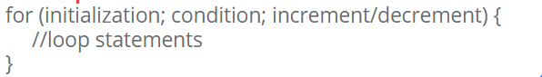

Block Diagram:

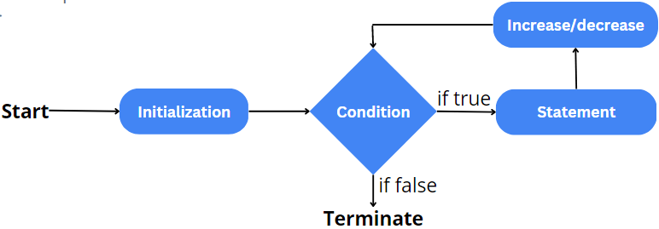

Example:



if you remove the statement one it will show a error that 'i' cannot be resolved. Also if you don't put any statement it will be an infinite loop.

Example:





If we have a for loop inside another loop, it is known as nested for loop. The inner loop executes completely whenever outer loop executes.

Syntax:

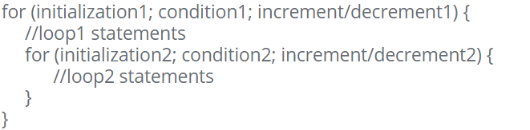

Example:

